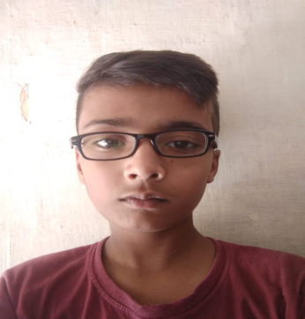
Resume

Saad Ansari
Email- Saadansirsaadansir@gmail.com
Mobile No - 7310528420

Personal Detail :-
Father : Anees ansari
Mother Name : Nazreen
DOB : 02/10/2008
Address : Deoband
Gender : Male
Nationlity : Indian
Marital Status : Unmarried
Career Objective:-
- Looking for challenging position in the field of Aviation
Qualification:-
- 10th Passed from UP Board

- 12th Passed from UP Board
Language Known
- Hindi & English
Hobbies:-
- Reading & Playing
Experience:-
- Computer Fresher
- Better Speaking

