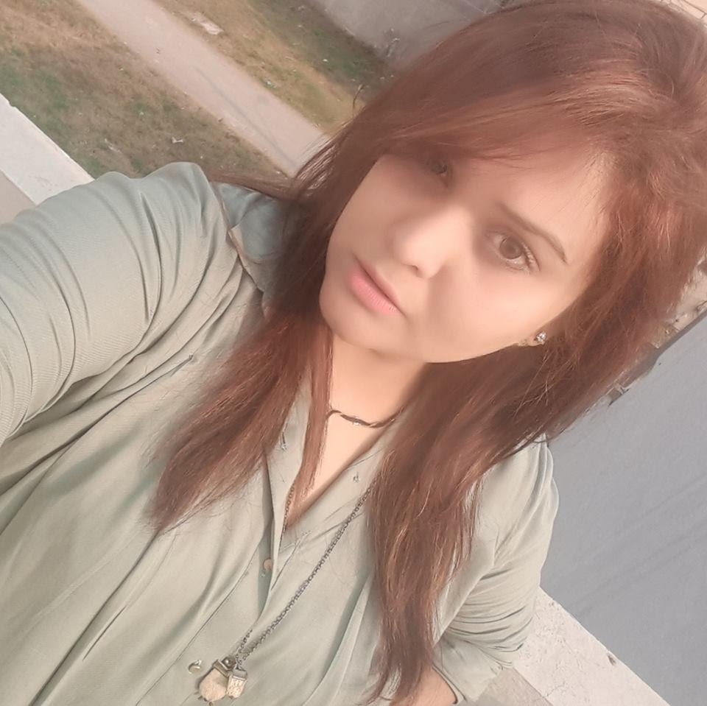Mahwish Bhattti
M: +971 5888 70523 / +92 322 5866663
E: mahwiiish@hotmail.com | Sharjah, UAE

SUMMARY
A result driven, self-motivated, and resourceful creative manager/copywriter with an ability to successfully translate desired moods, messages, concepts, and underdeveloped ideas into imagery. Experience of working in and contributing to a creative environment alongside designers, copywriters, content strategists, user experience specialists and interactive developers.
- POS, merchandising, press, outdoor, DM, brochures and digital. Excellent presentation and communication skills.
- Ability to prioritize and juggle multiple projects within tight deadlines.
- Capable of developing and communicating leading creative concepts.
- Strong conceptual thinking-- both visual and interactive. Knowledge of design disciplines including layout, typography, imagery & color.
- Knowledge of video and After Effects.
- Strong proof of concept, rapid prototyping, storyboarding & technical skills.

EXPERTISE
Tools | Competencies | Technical Skills
- MS Word  - MS PowerPoint  - Adobe Photoshop  - Adobe Illustrator  - Google Analytics | - Constructive  - Risk Management  - Charismatic  - Smart Worker  - Visionary  - Passionate  - Innovative  - Team management  - Client facing  - Ability to sell design | - Video Production/Editing  - Photography  - Sculptures  - Creative Artwork  - Event Management  - Copywriting  - Graphics Designing  - Script Writing  - Pitching Ideas  - Pre-/Post- Production  - Hosting (On Stage & Media Channels)  - Creative Writing  - Product Branding
EXPERIENCE

09/2018 – 09/2021 Digital Creative Director | Digihyve - digital ad agency
At Digihyve digital agency, I was responsible for the growth of the brand, amplifying our story, and bringing the company’s vision to life.as creative director, I worked with the core team and partnered closely with other groups to ensure consistent application of the brand's guidelines and philosophy.
- Developed a strong point-of-view of the brand and guide the company in creating a compelling, differentiated brand.
- Owned the branding, design, and voice of all creative outputs from website and emails to ads and customer videos, to events and presentations, to tradeshow booths and company swag.
- Provided creative direction to ensure a cohesive, polished visual identity and voice across everything we do, while balancing the trade-offs required to move quickly in a high-growth company.
- Defined a design process from ideation and concept to implementation and delivery for smooth execution of all creative digital projects.
- Collaborated cross-functionally on creative needs across the company and build closer connections with the product design practice.

01/2017 – 08/2018 Deputy Creative & Media Manager | Minha Edible Oils, Pakistan
- Directing workflow of NRS international specialists.
- Facilitating interdepartmental communications and managing external communications to the team.
- Allocating company resources to maximize collaboration, efficiency and creativity in building and maintenance of brand consistency or corporate identity across marketing and public relations channels.
- Keep myself updated on industry trends.
- Developing and refinement of marketing goals.
- Managing promotional creative strategies and brand communication.
- Handling public's perception of a product, brand, or company.
- Managing company newsletter content, social media channels, website content and documentary development.

02/2014 – 12/2016 Head Media Communications | Haier, Pakistan
- Directing workflow of marketing, advertising, or public relations specialists.
- Assigning job tasks, facilitating interdepartmental communications, and managing external communications to the team.
- Allocating company resources to maximize collaboration, efficiency and creativity in building and maintenance of brand consistency or corporate identity across marketing and public relations channels.
- Keep myself updated on industry trends.
- Managing all external/internal communications of the department.
- Developing and refinement of marketing goals.
- Managing promotional creative strategies and brand communication.
- Handling the public's perception of a product, brand, or company.
- Directing the creation of internal communications, press releases and speeches of executives, web, and social media presence.
- Managing company newsletter content, social media channels, website content and documentary development.

12/2013 – 12/2014 Creative Director | Punjab Sports Board, Pakistan
- Creative Director for Punjab Youth Festival 2014
- Worked as a conceptual team leader.
- Directed and enhanced the efforts of a creative team consisting of designers, information architects, illustrators, interface developers and flash artists.
- Applied conceptual strategy, brainstorm facilitation, day-to-day shepherding of a project to completion and team play with engagement managers, production, and technology leads.
- Keeping the team aware of the latest industry trends of communications.
- Developed and executed creative concepts for marketing and web solutions.
- Worked for electronic media, print media and radio.

08/2013 – 11/2013 Associate Creative Director | Velocity Advertising, Pakistan
- Directed and enhanced the efforts of a creative team consisting of designers, information architects, illustrators, interface developers and flash artists.
- Applied conceptual strategy, brainstorm facilitation, day-to-day shepherding of a project to completion and team play with engagement managers, production, and technology leads.
- Developed and executed creative concepts for branding solutions.

05/2012 – 07/2013 Creative Manager / Copy Writer | Midas, Pakistan
Responsible for developing and executing creative concepts for leading-edge marketing and web solutions. Regularly liaising with the technology team to ensure the best creative solutions are realized, implemented, and delivered.
- Developed innovative and creative concepts across all media.
- Worked with other project managers and teams of creative designers.
- Developed creative concepts according to client requirements.
- Communicated design visions and rationale clearly to clients and design teams. Conceptualized, visualized, and designed user experiences.
- Managed and directed photo shoots on time and to budget.
- Involved in developing the client’s culture and quality standards.
- Attended conferences, press releases, exhibitions, and expos.
- Mentored junior staff in project development and performance management.
- Organized, initiated, and led brainstorms sessions.

2011 – 2012 Creative Manager / Copy Writer | Interlink Advertising, Pakistan
Responsible for developing and executing creative concepts for leading-edge marketing and web solutions. Regularly liaising with the technology team to ensure the best creative solutions are realized, implemented, and delivered.
- Developed innovative and creative concepts across all media.
- Worked with other project managers and teams of creative designers.
- Developed creative concepts according to client requirements.
- Communicated design visions and rationale clearly to clients and design teams. Conceptualized, visualized, and designed user experiences.
- Managed and directed photo shoots on time and to budget.
- Involved in developing the client’s culture and quality standards.
- Attended conferences, press releases, exhibitions, and expos.
- Mentored junior staff in project development and performance management.
- Organized, initiated, and led brainstorms sessions.

2011 Freelance Internship | WWF, Pakistan
- Managing the overall design in the company regarding print medium, social media, and creative design layouts

2006 Graphic Designing & Copywriting | G4B, Pakistan
- Managing the overall design in the company regarding print medium.
- Communication with client(s) regarding all the campaigns.
- To assist all the crew in day-by-day meetings with the latest updates regarding products in terms of designing.
- Copywriting for the products.

FREELANCE EXPERIENCE

COMPANY PROFILE DESIGNING

2009 BULLET 360 (PVT) LTD.

2009 SOLAR TECH (PVT) LTD.

2008 ENGLISH PHARMACEUTICALS

ACTIVITIES
- Managing the overall design of company regarding print medium and web.
- Communication with client(s) regarding all the campaigns.
- Performed commercial interactive company profile

EDUCATION
2007 – 2011 BS (Honors) – Theatre / TV Production
Beaconhouse National University (BNU), Pakistan

ACHIEVEMENTS / CERTIFICATIONS
- Certification: Australian Documentary Maker (Workshop)
- Training: Photography from NCA.
- Achieved: 2nd position in poster designing competition arranged and organized by NGO, named as ALIF LAILA.

LANGUAGES
- Good effective command over English, Urdu & Punjabi with excellent communication skills.
- Also have knowledge and reasonable command over French Language.

